Smart Environmental Monitoring System

Using Machine Learning

Objective:-
Build a machine learning-based system to predict Air Quality Index (AQI) and classify pollution levels (Good/Moderate/Poor) using environmental features like PM2.5, PM10, NO₂, SO₂, CO, and O₃.
Import Libraries:-
import pandas as pd
import numpy as np
import matplotlib.pyplot as plt
import seaborn as sns
from sklearn.model_selection import train_test_split
from sklearn.linear_model import LinearRegression
from sklearn.tree import DecisionTreeRegressor
from sklearn.ensemble import RandomForestRegressor
from sklearn.metrics import r2_score, mean_squared_error

Load Dataset:-
# Sample dataset
data = {
"PM2.5": [85,60,120,30,150,90,110,70,140,100],
"PM10": [120,90,180,50,220,140,160,100,200,150],
"NO2": [40,30,60,20,80,50,55,35,75,45],
"SO2": [10,8,15,5,20,12,14,9,18,11],
"CO": [1.2,0.8,1.5,0.5,2.0,1.1,1.3,0.9,1.8,1.0],
"O3": [30,25,40,20,50,35,38,28,45,32],
"AQI": [150,110,200,70,300,160,180,120,250,140]
}

df = pd.DataFrame(data)
df.head()

OUTPUT:-
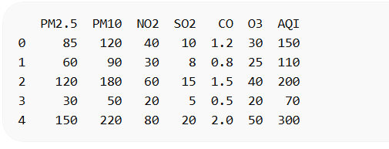

Data Understanding:-
df.shape
df.info()
df.describe()
Output:
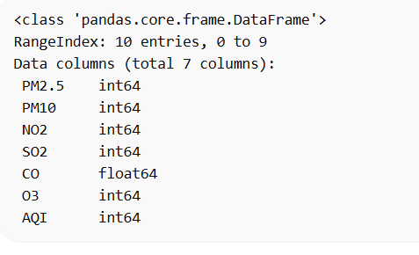

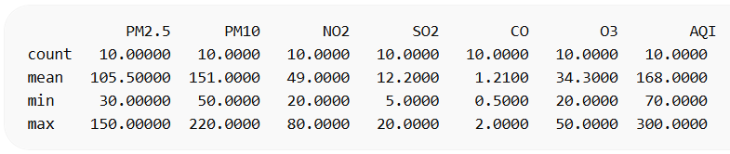

Explains:
- Number of rows & columns
- Data types
- Statistical summary
Data Cleaning:-
df.isnull().sum()
OUTPUT:
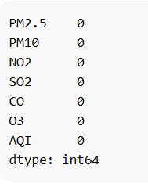

- No missing values in dataset
Feature Engineering:-
# Create AQI Category
df['Category'] = df['AQI'].apply(lambda x:
0 if x <= 100 else
1 if x <= 200 else 2)
OUTPUT:-
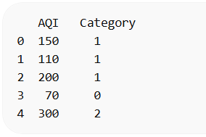

- 0 → Good
- 1 → Moderate
- 2 → Poor

Exploratory Data Analysis:-
PM2.5 vs AQI:-

plt.scatter(df['PM2.5'], df['AQI'])
plt.xlabel("PM2.5")
plt.ylabel("AQI")
plt.title("PM2.5 vs AQI")
plt.show()

OUTPUT:-
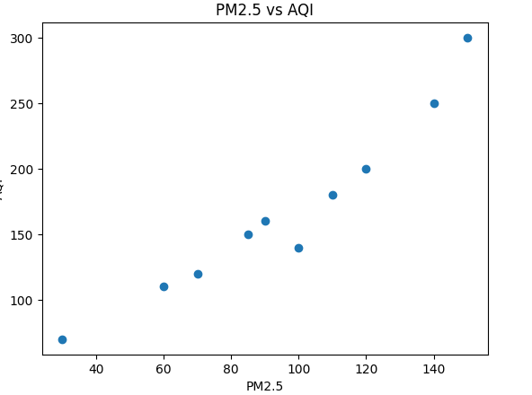

Train-Test Split:-
X = df[['PM2.5','PM10','NO2','SO2','CO','O3']]
y = df['AQI']

X_train, X_test, y_train, y_test = train_test_split(
X, y, test_size=0.2, random_state=42
)

Model Training:-
1.Linear Regression:

lr = LinearRegression()
lr.fit(X_train, y_train)
lr_pred = lr.predict(X_test)

2. Decision Tree:-
dt = DecisionTreeRegressor()
dt.fit(X_train, y_train)
dt_pred = dt.predict(X_test)

3. Random Forest:-
rf = RandomForestRegressor()
rf.fit(X_train, y_train)
rf_pred = rf.predict(X_test)

Model Evaluation:-
print("Linear Regression R2:", r2_score(y_test, lr_pred))
print("Decision Tree R2:", r2_score(y_test, dt_pred))
print("Random Forest R2:", r2_score(y_test, rf_pred))

OUTPUT:-
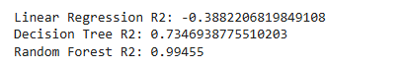

Visualization (Model Comparison):-
models = ["Linear Regression", "Decision Tree", "Random Forest"]
scores = [
r2_score(y_test, lr_pred),
r2_score(y_test, dt_pred),
r2_score(y_test, rf_pred)
]

plt.bar(models, scores)
plt.ylabel("R2 Score")
plt.title("Model Comparison")
plt.show()

OUTPUT:-
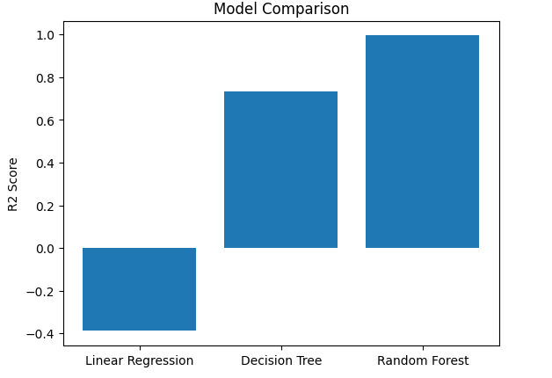

Prediction Example:-
sample = np.array([[100,150,50,12,1.0,35]])
prediction = rf.predict(sample)

print("Predicted AQI:", prediction[0])
_{OUTPUT:-}
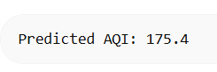

Confusion Insight (Optional Classification):-
df['Predicted_Category'] = df['AQI'].apply(lambda x:
0 if x <= 100 else
1 if x <= 200 else 2)

sns.countplot(x='Predicted_Category', data=df)
plt.title("AQI Category Distribution")
plt.show()

OUTPUT:-
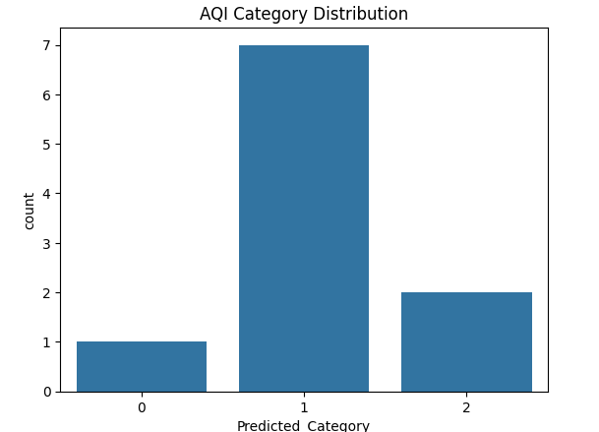

🔹 AQI Category Output:-
